TOPIC 5: GREEDY
Q1. Coin Triplet Aim:
To maximize coins collected following selection rules using greedy choice.

Algorithm:
- Sort piles descending.
- Form triplets.
- Alice takes largest, Bob smallest, you middle.
- Sum your selected coins.
- Return maximum total.

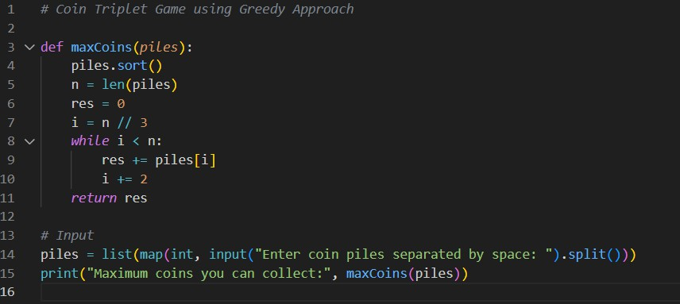
Input:

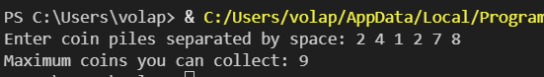
Output:

Result: The program correctly selects coins using the greedy strategy to maximise the total value. It outputs the highest possible sum of coins collected.

To find shortest distance from a source to all vertices using Dijkstra’s algorithm.

Algorithm:
- Read adjacency matrix.
- Initialize distances = ∞.
- Set distance[source]=0.
- Update distances using relaxation.
- Return final shortest path list.

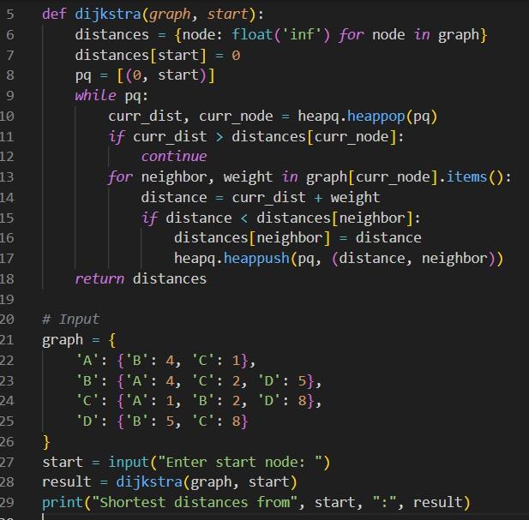
Input:

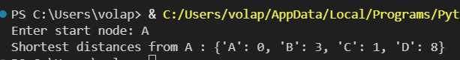
Output:

Result: The shortest path from the source node to all others is computed efficiently. The greedy edge selection ensures minimum total distance.

To generate optimal prefix codes using Huffman tree.

Algorithm:
- Create a min-heap of character frequencies.
- Extract two smallest nodes.
- Merge them into a new internal node.
- Repeat until one node left.
- Assign binary codes.

Input:
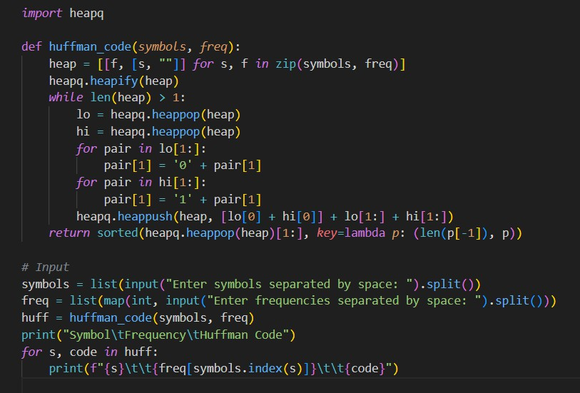

Output:
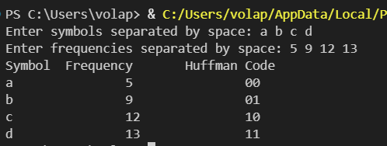
Result: The algorithm generates optimal binary prefix codes for each symbol. It reduces average code length, achieving data compression.

To find a minimum spanning tree of a connected graph.

Algorithm:
- Sort edges by weight.
- Initialize disjoint sets.
- Add edge if no cycle formed.
- Repeat until n − 1 edges.
- Output MST and total cost.

Input:
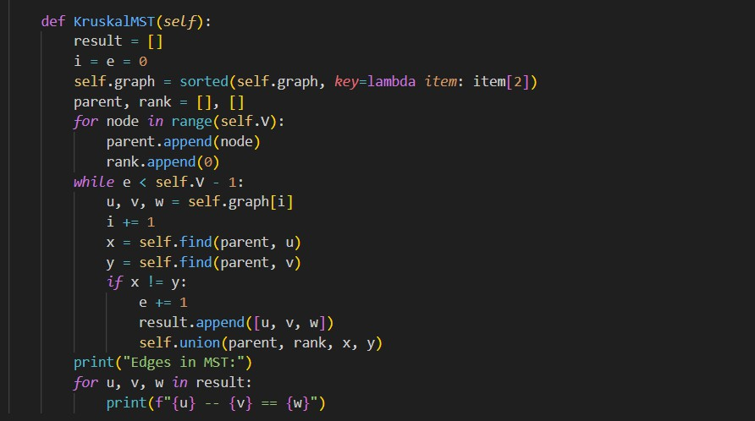

Output:

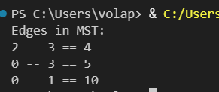
Result: The program constructs a minimum-cost spanning tree using edge-weight sorting.It ensures all vertices are connected with minimal total cost.

To maximize profit by selecting items partially using greedy ratio sorting.

Algorithm:
- Read weights & values.
- Compute value/weight ratio.
- Sort descending by ratio.
- Pick items until full capacity.
- Add fraction if partial fit.

Input:
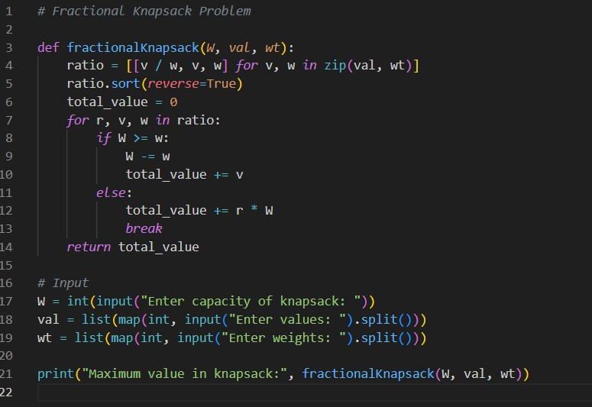

Output:
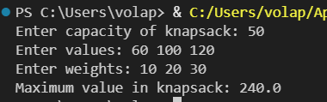

Result: The greedy selection by value-to-weight ratio maximises total profit. It achieves the optimal fractional solution within given capacity.

